# ISLAMIC UNIVERSITY OF TECHNOLOGY

# Organization of Islamic Cooperation

# Board Bazar, Gazipur

# Lab 02

# Study of Wave Shapes of Different Types of Clipping and Clamping Circuits using PSIM

# EEE 4484

**Part A – Clipper Circuits**

**Series Unbiased Positive Clipper Circuit**

Circuit Diagram



Wave Shapes

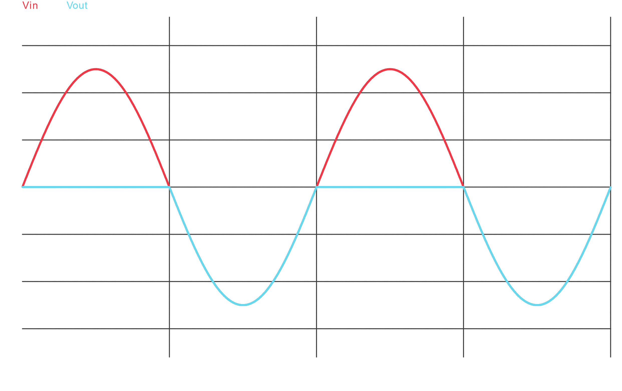

**Series Unbiased Negative Clipper Circuit**

Circuit Diagram



Wave Shapes

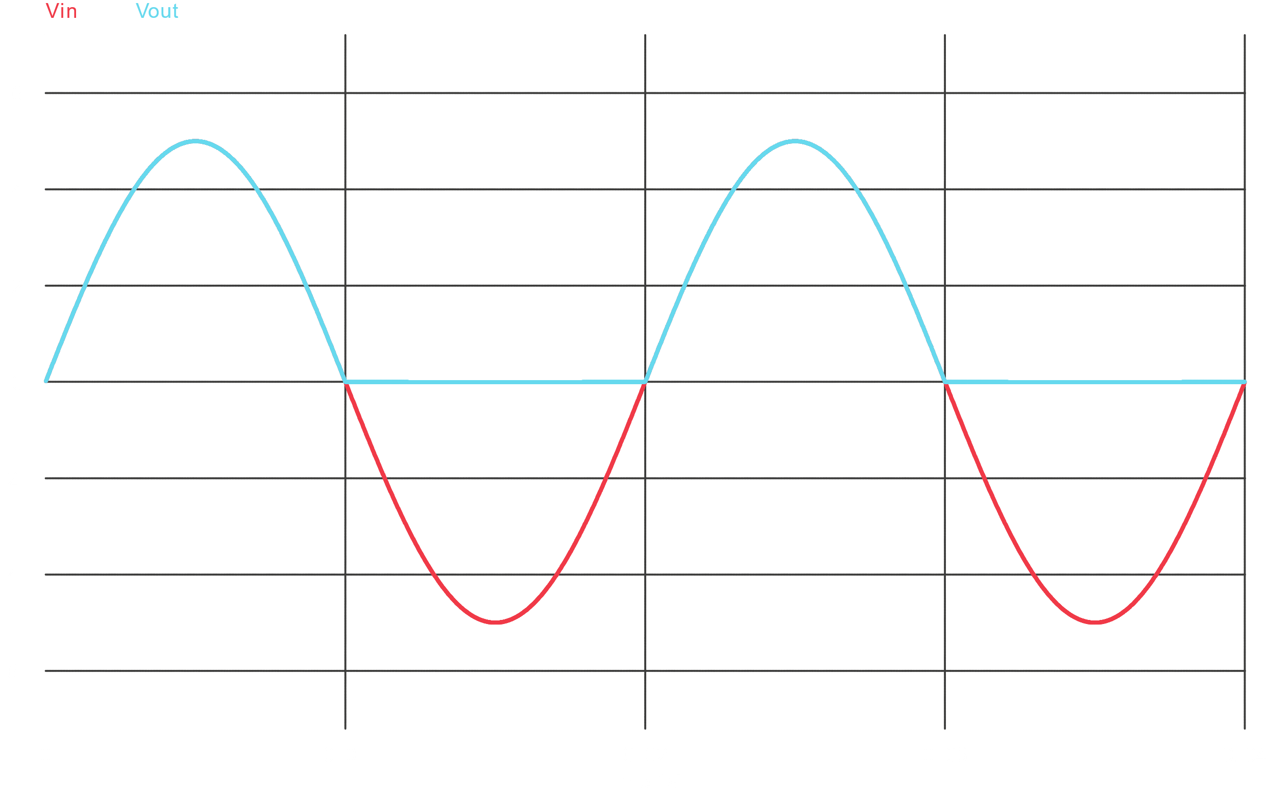

**Parallel Unbiased Clipper Circuit**

Circuit Diagram



Wave Shapes

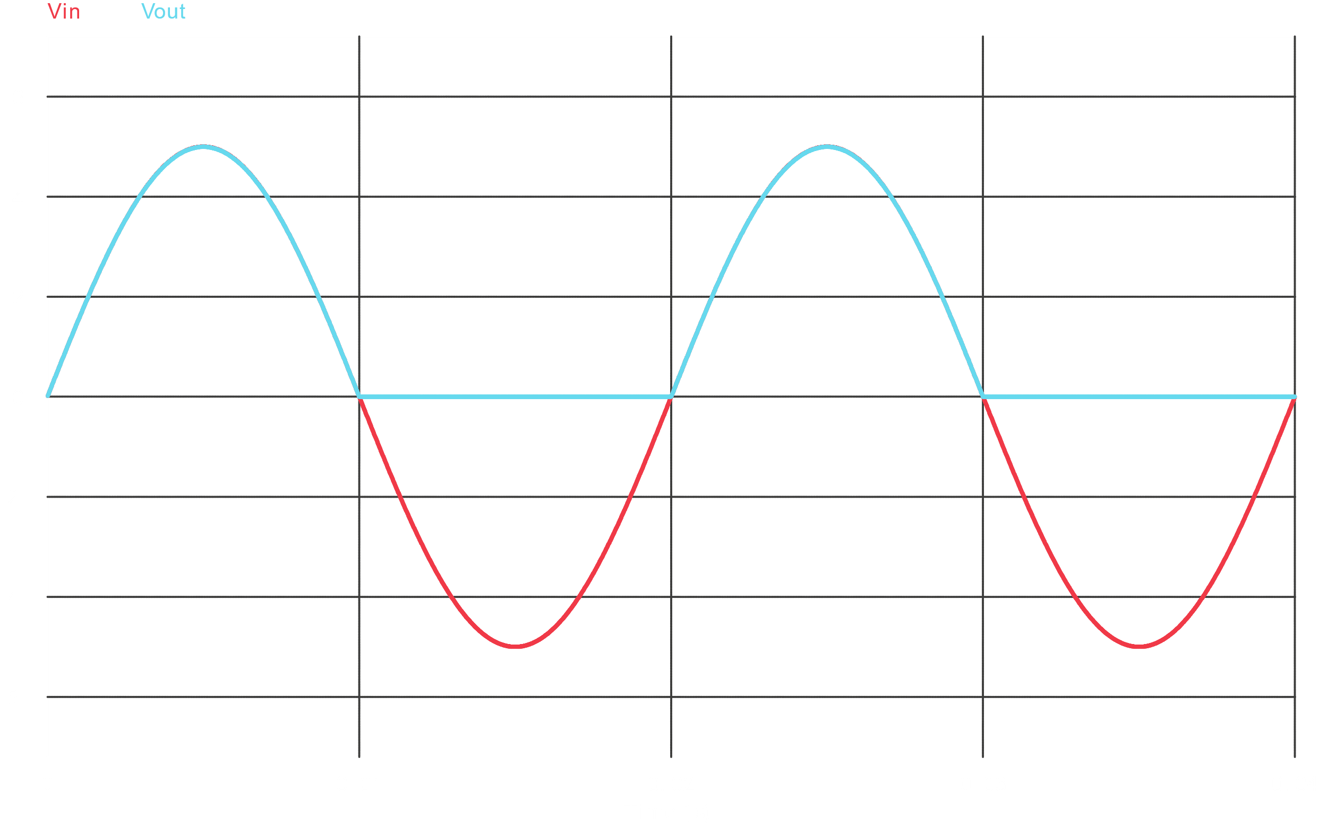

**Series Biased Positive Clipper Circuit**

Circuit Diagram



Wave Shapes

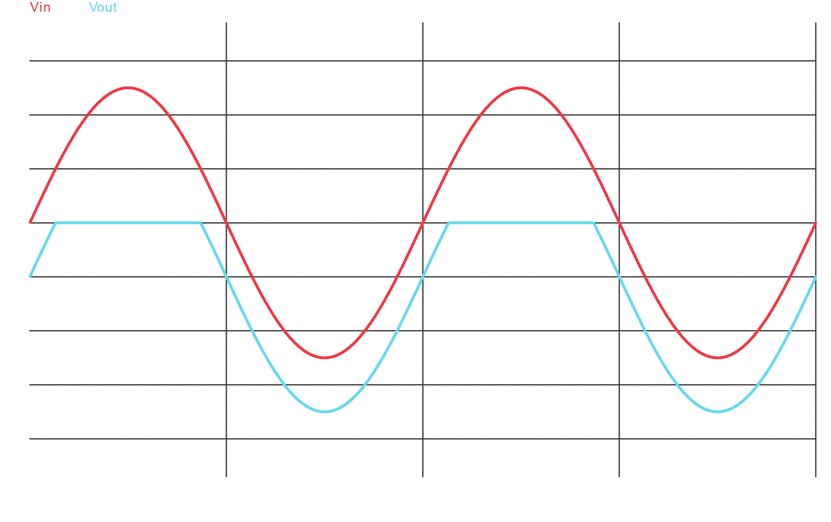

**Series Biased Negative Clipper Circuit**

Circuit Diagram



Wave Shapes

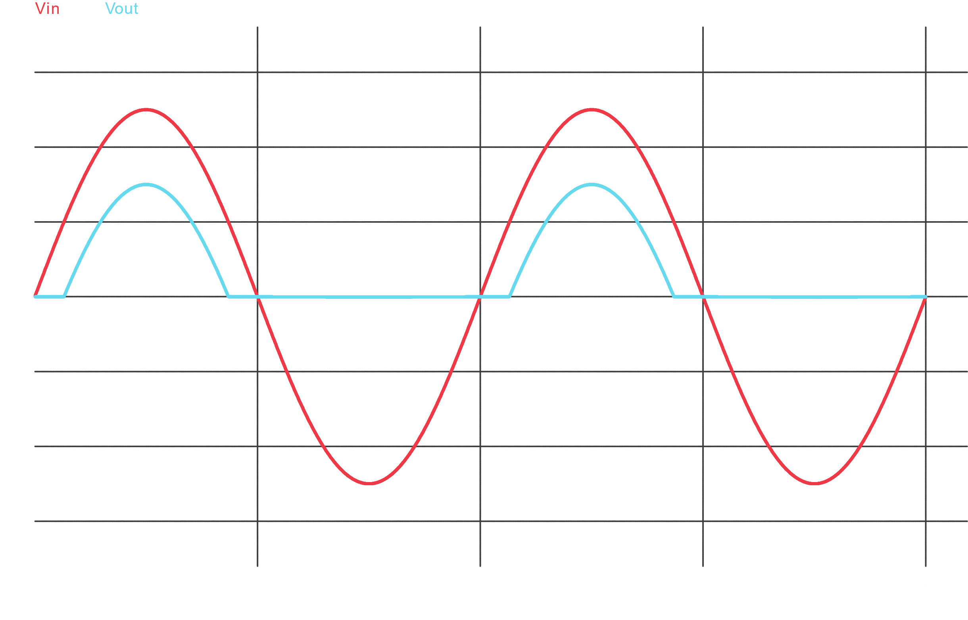

**Parallel Biased Positive Clipper Circuit**

Circuit Diagram



Wave Shapes

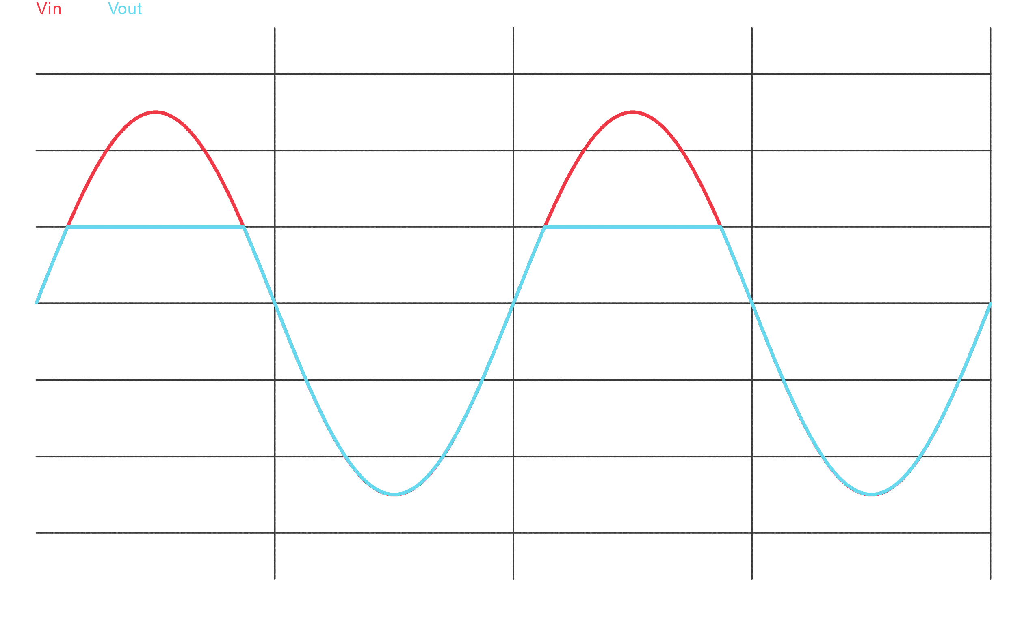

**Parallel Biased Negative Clipper Circuit**

Circuit Diagram



Wave Shapes

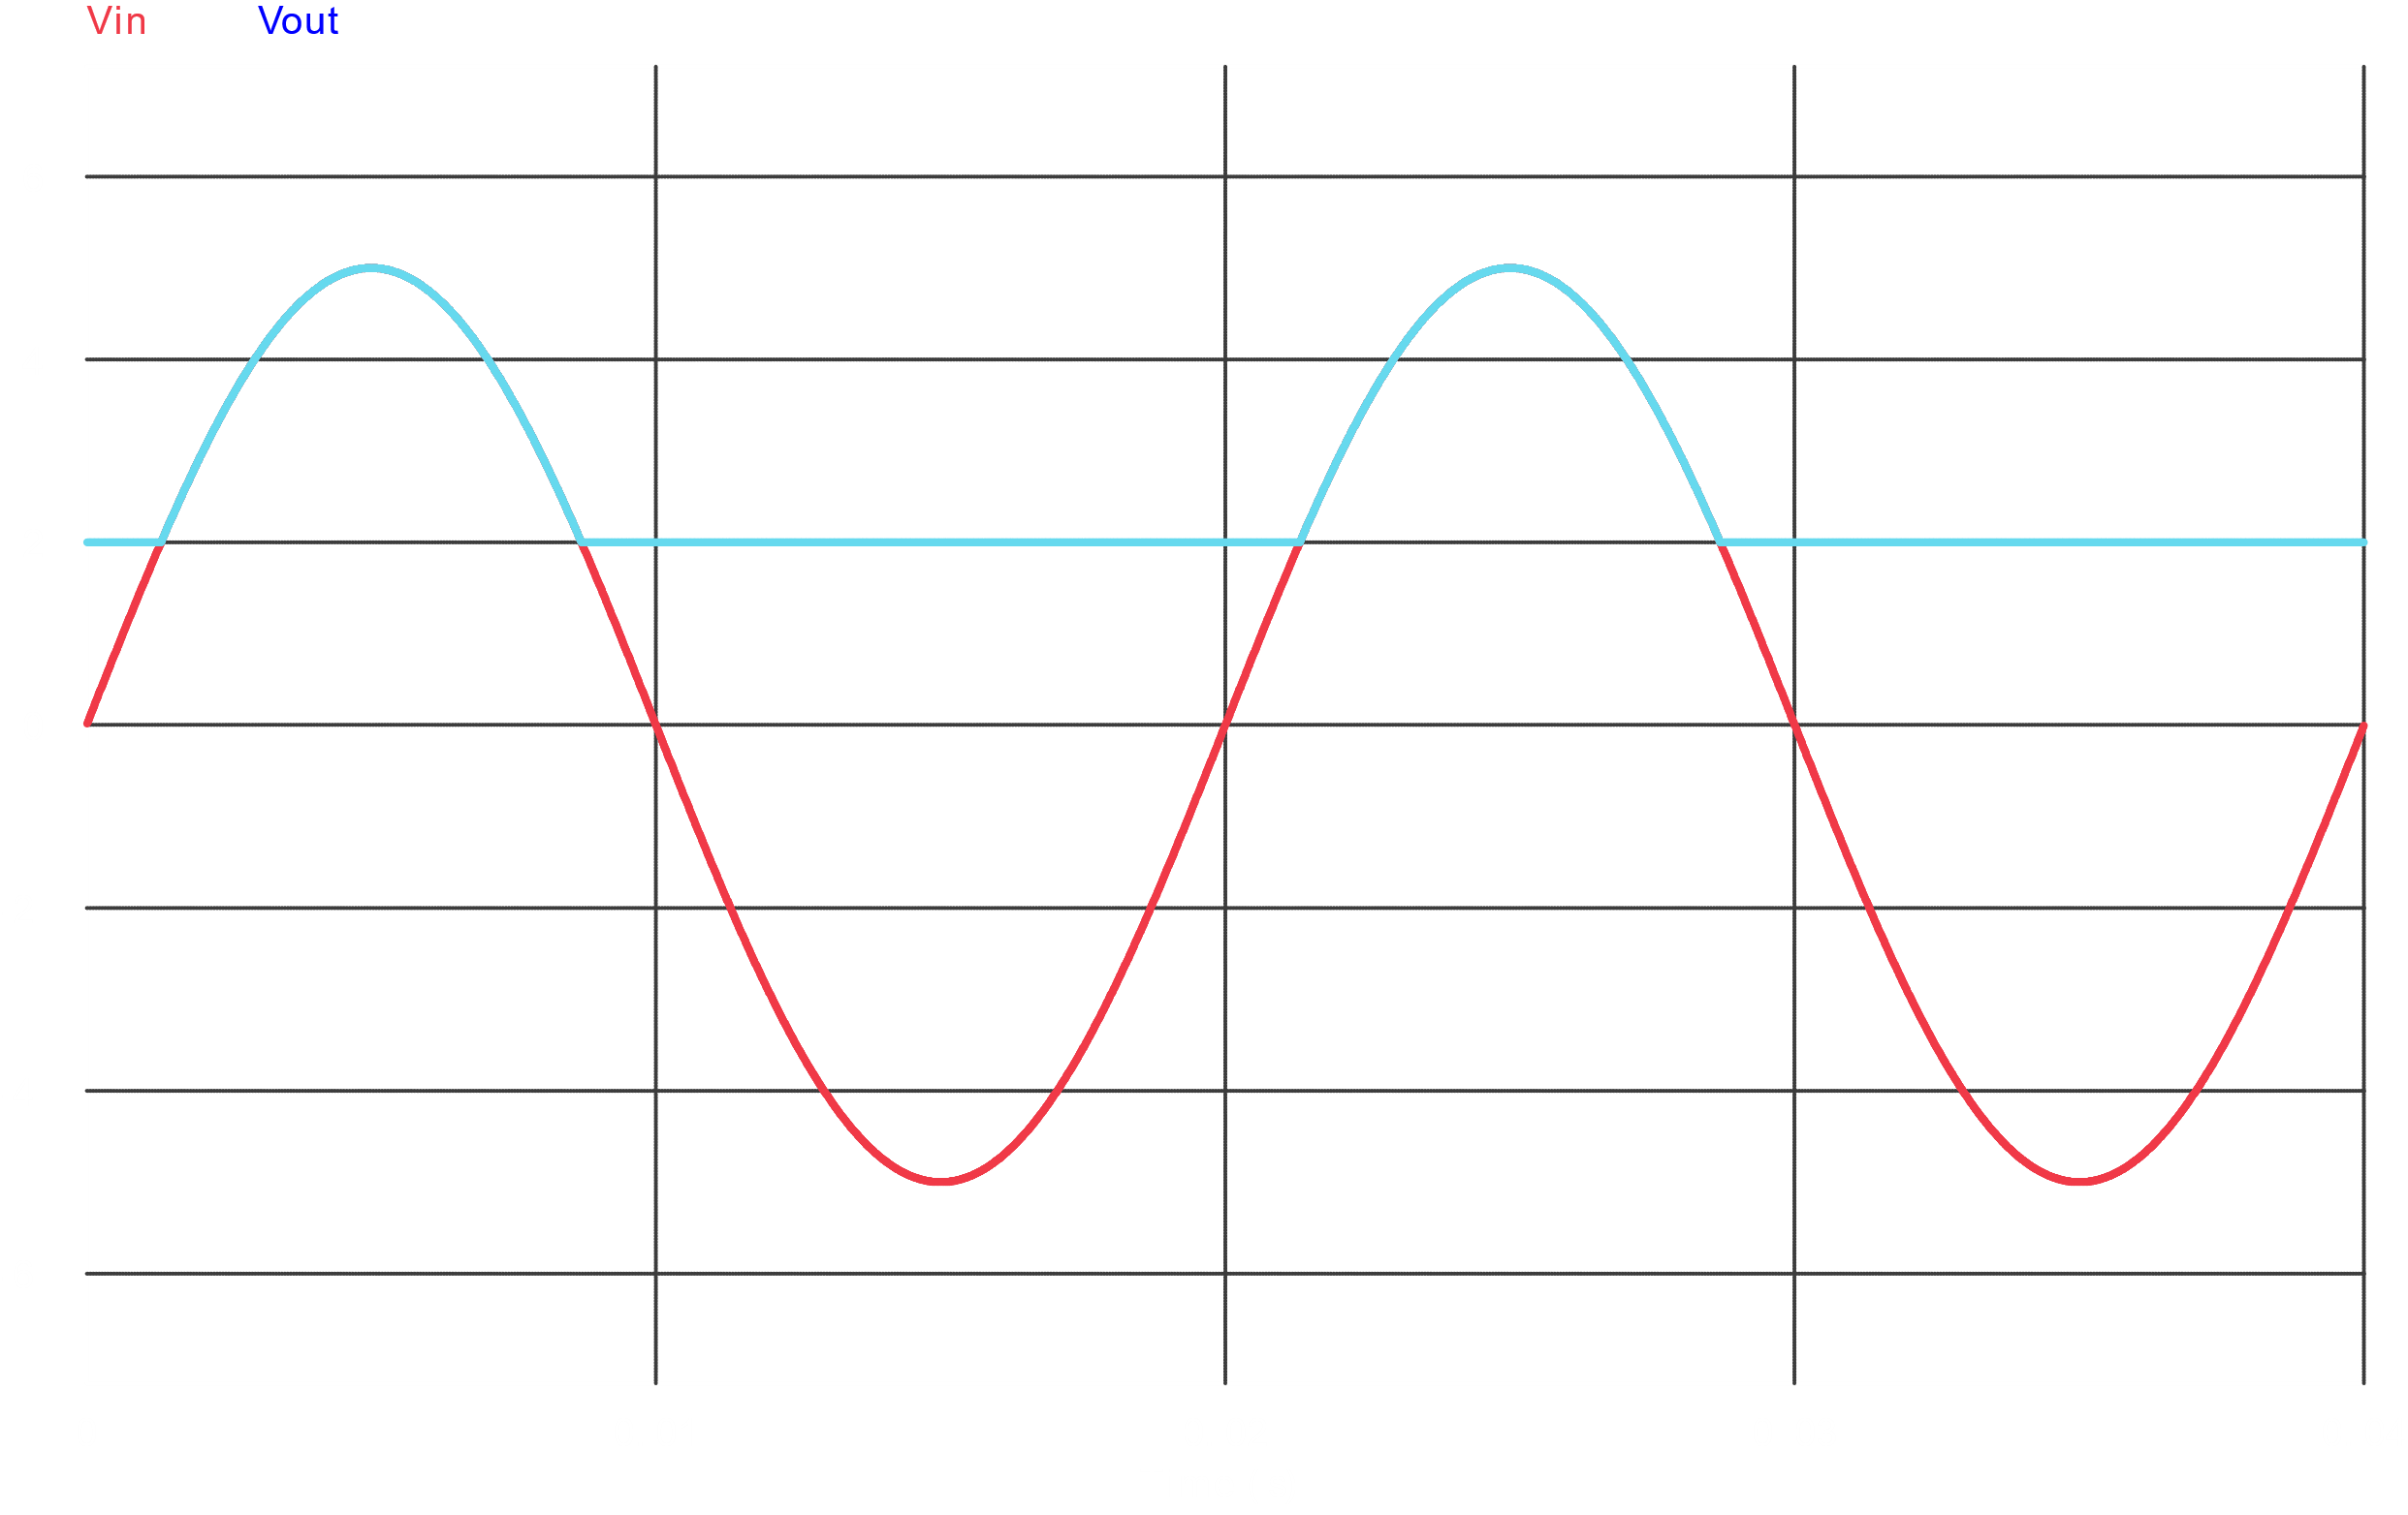

**Parallel Biased Combined Clipper Circuit**

Circuit Diagram



Wave Shapes

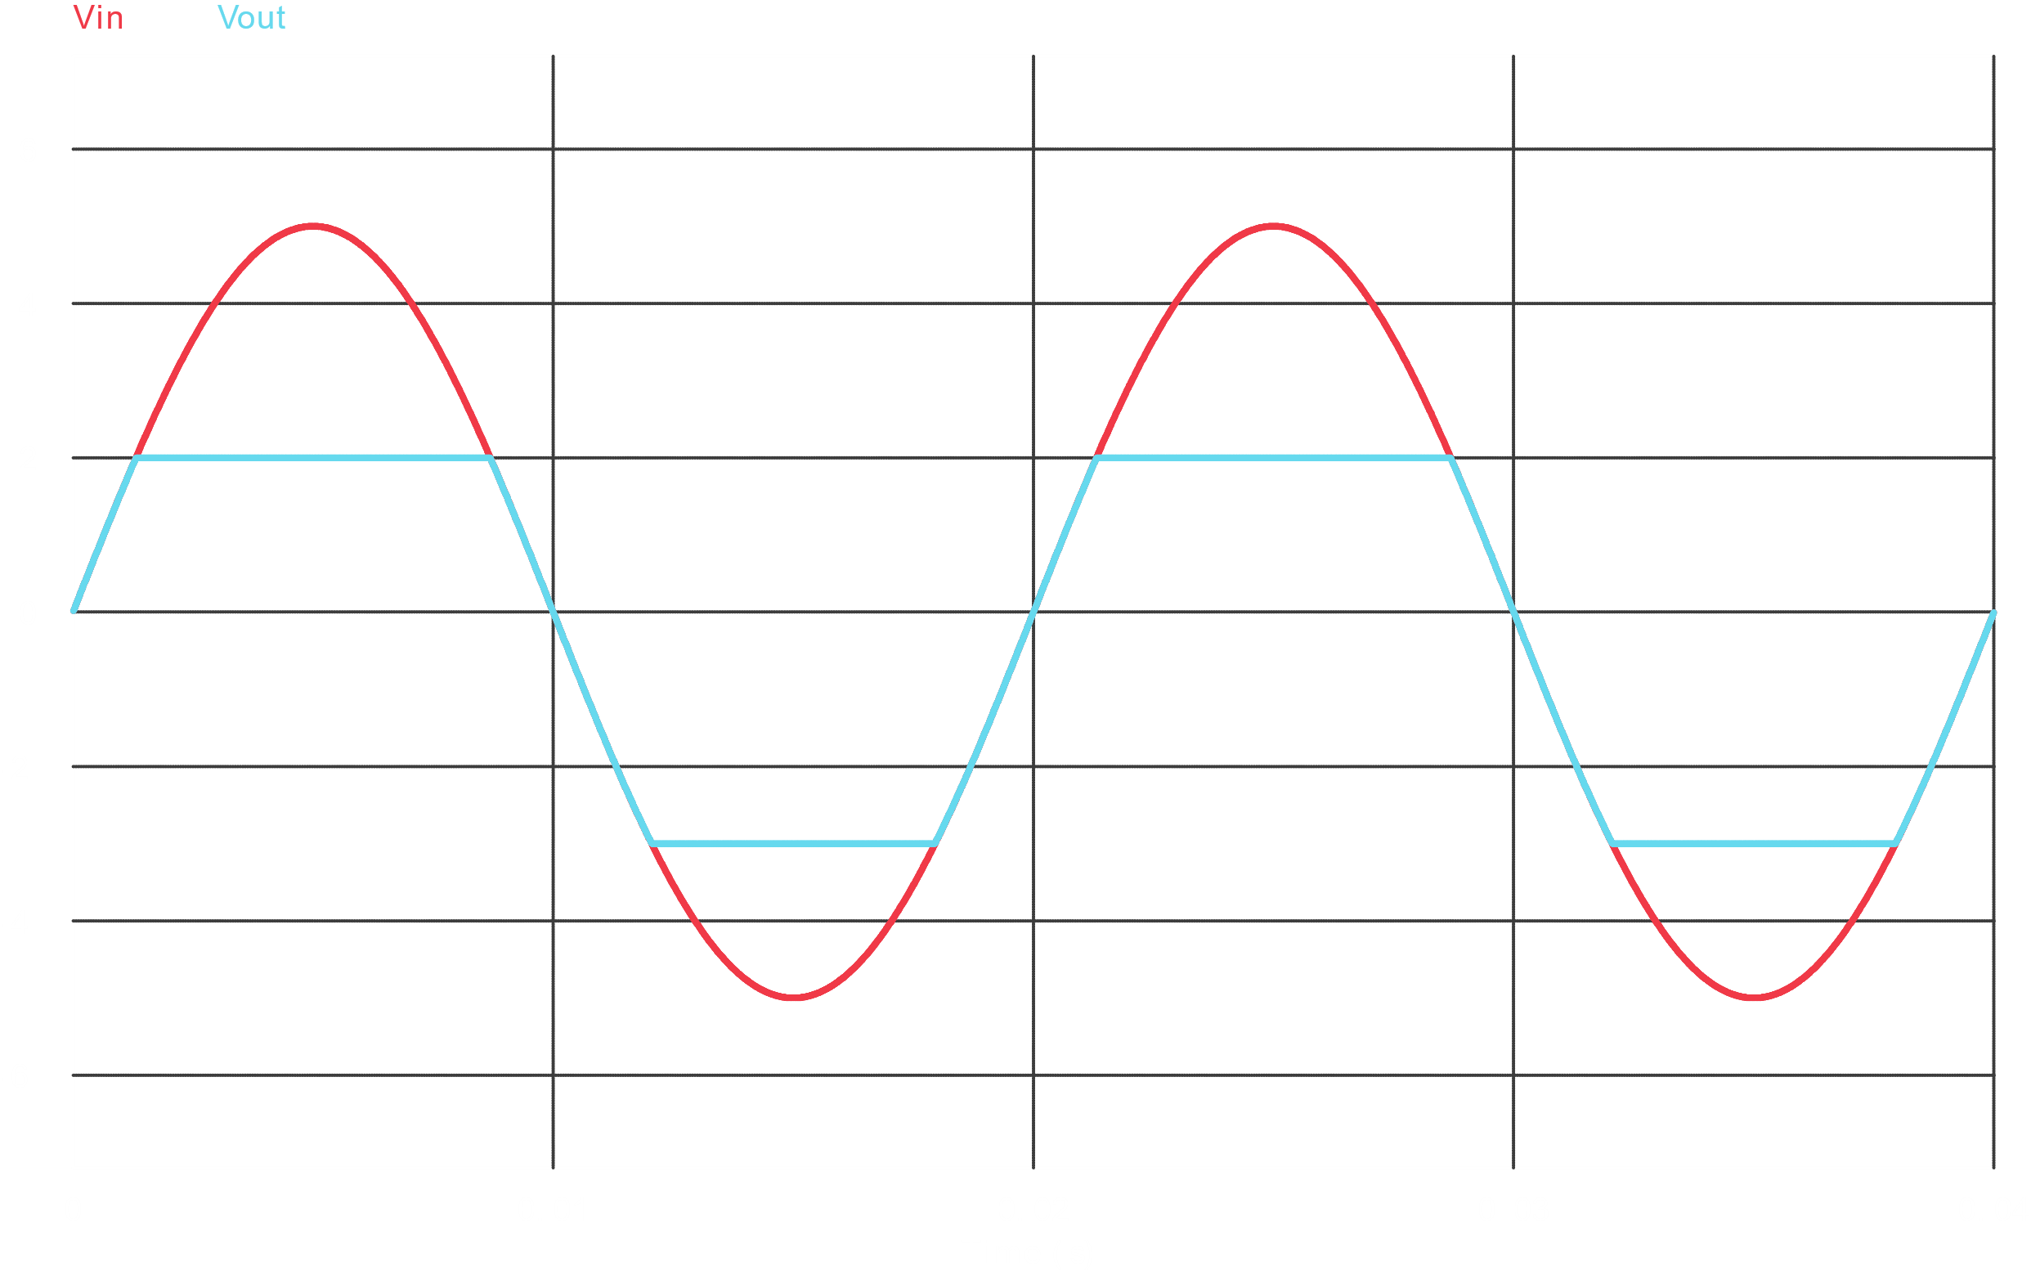

**Part B – Clamper Circuits**

**Series Unbiased Positive Clamper Circuit**

Circuit Diagram



Wave Shapes

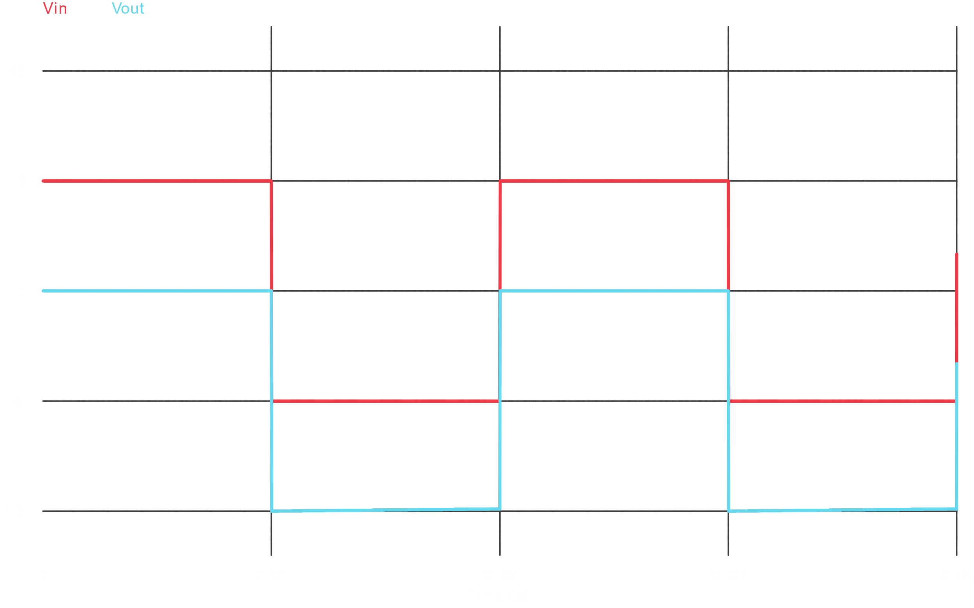

**Series Unbiased Negative Clamper Circuit**

Circuit Diagram



Wave Shapes

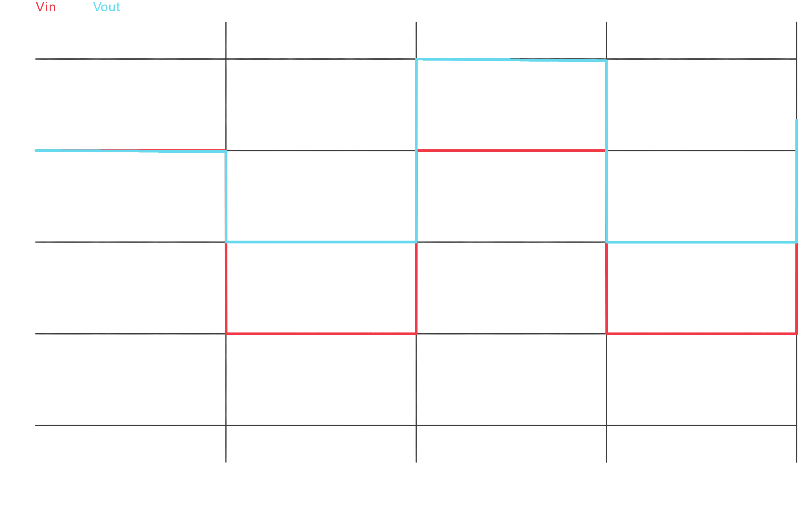

**Series Biased Positive Clamper Circuit**

Circuit Diagram



Wave Shapes

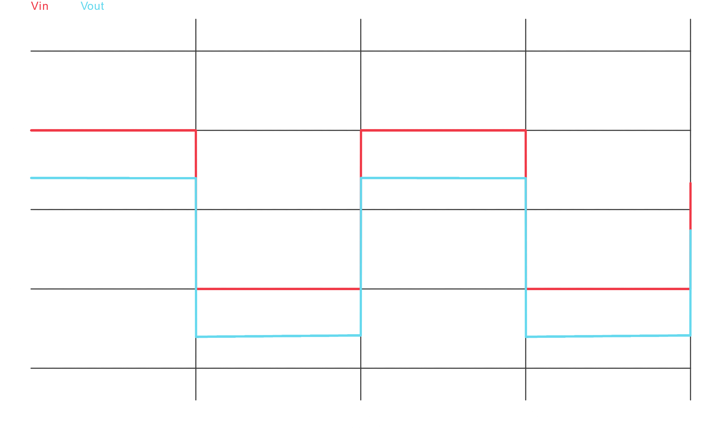

**Series Biased Negative Clamper Circuit**

Circuit Diagram



Wave Shapes

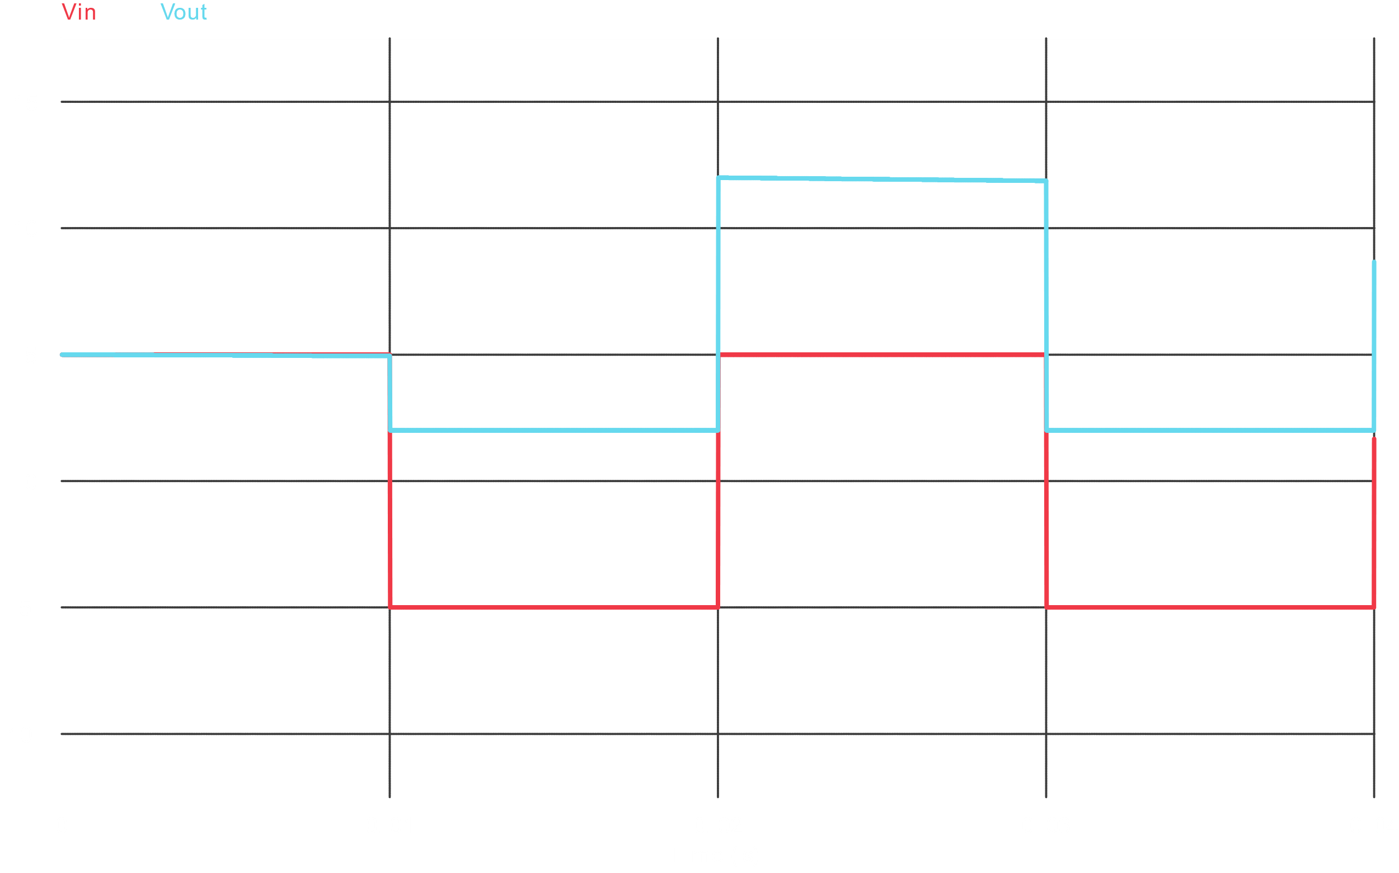

**Assignment**

**Problem 1**

Circuit Diagram



Wave Shapes

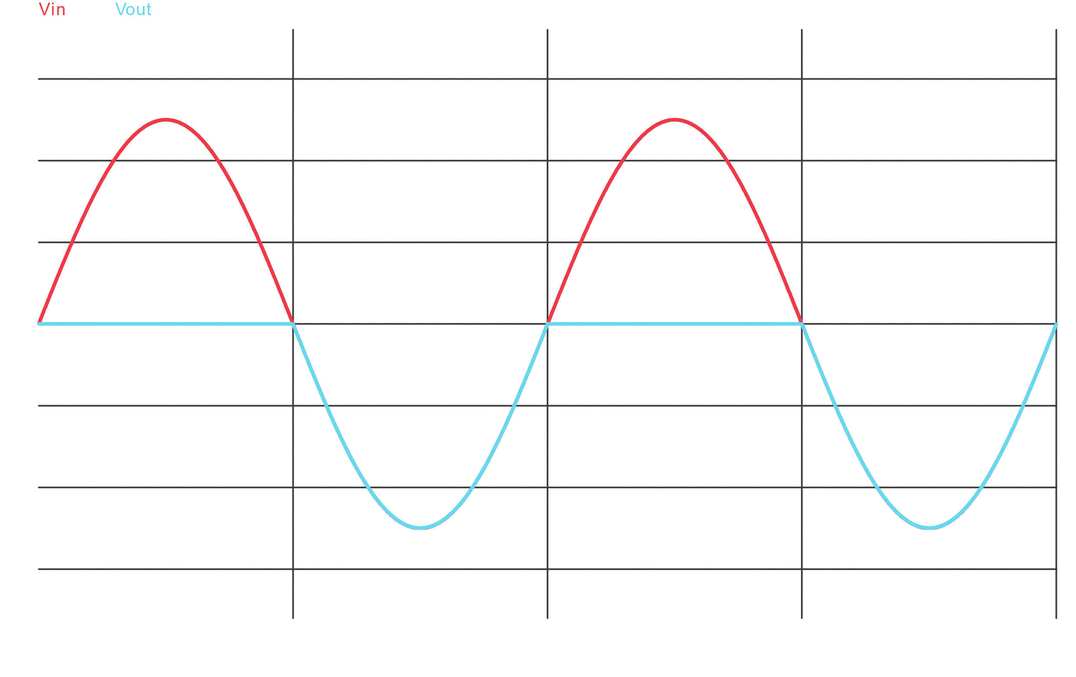

**Problem 2**

Circuit Diagram



Wave Shapes

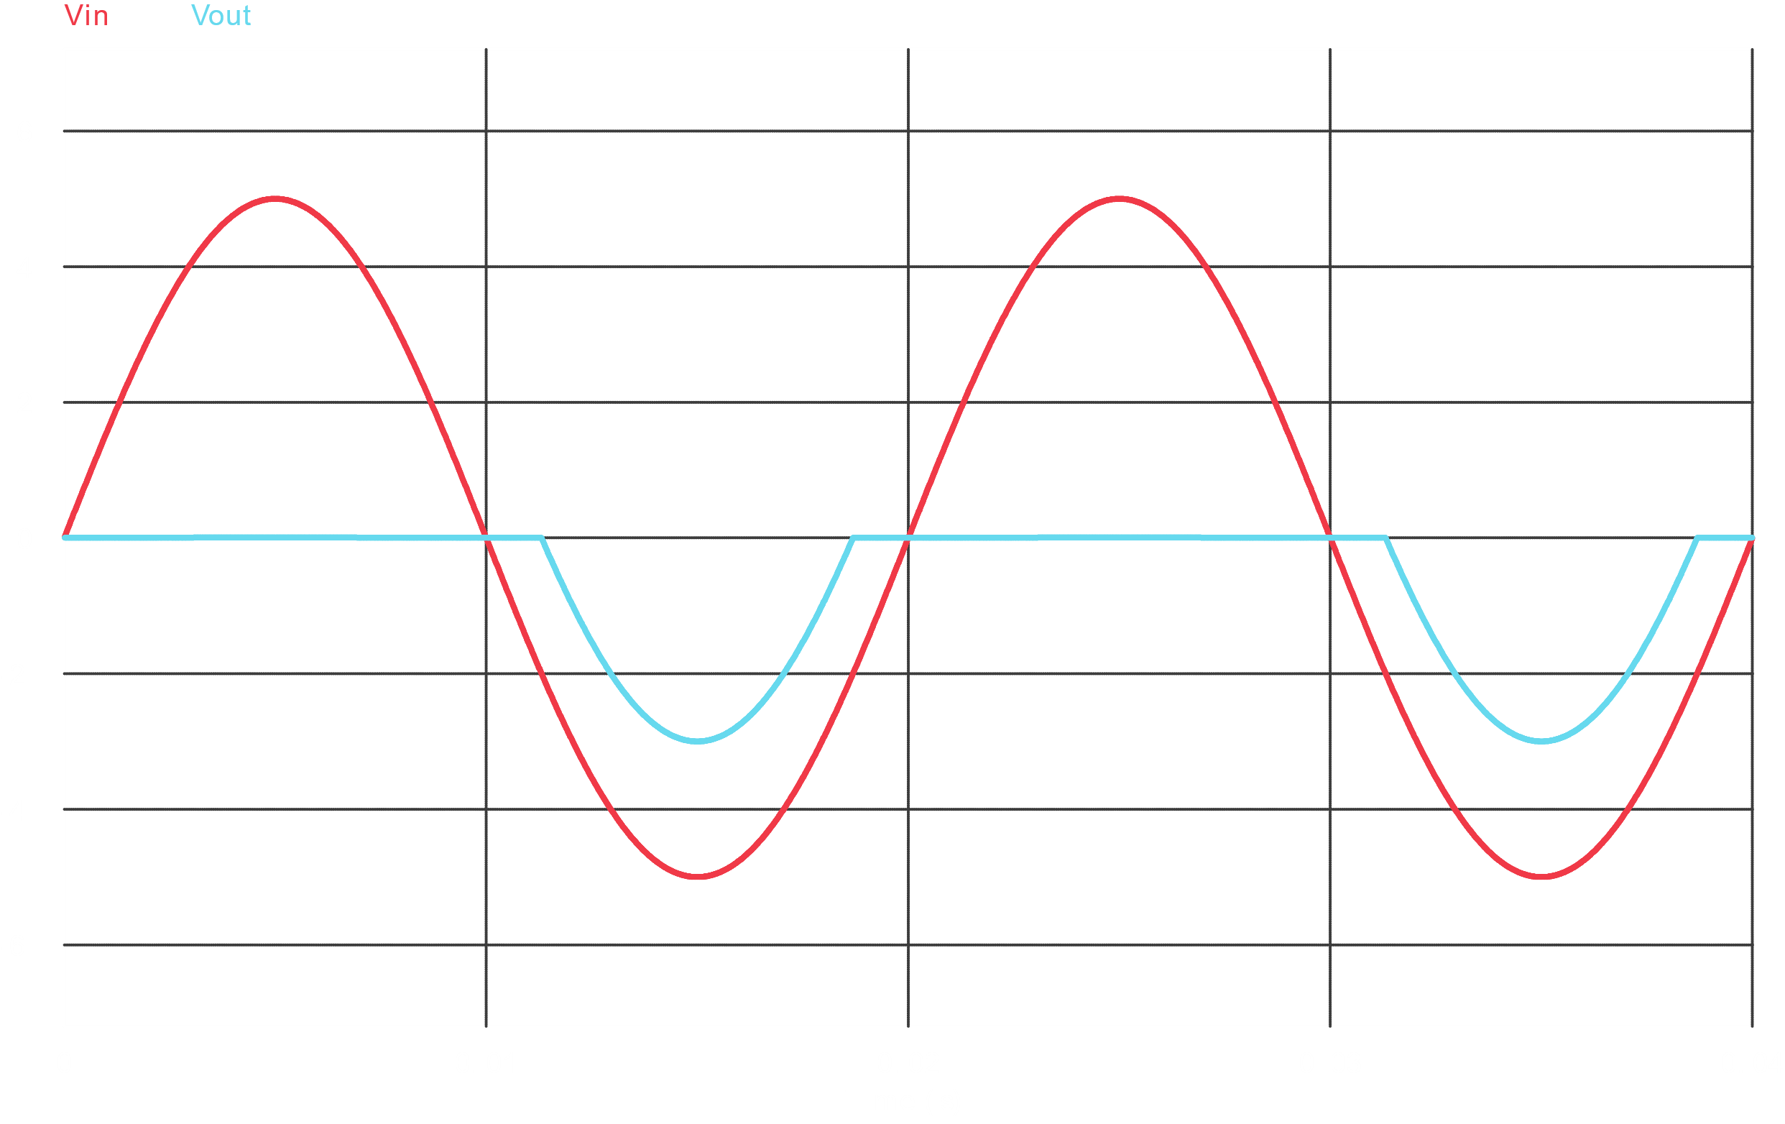

**Problem 3**

Circuit Diagram



Wave Shapes

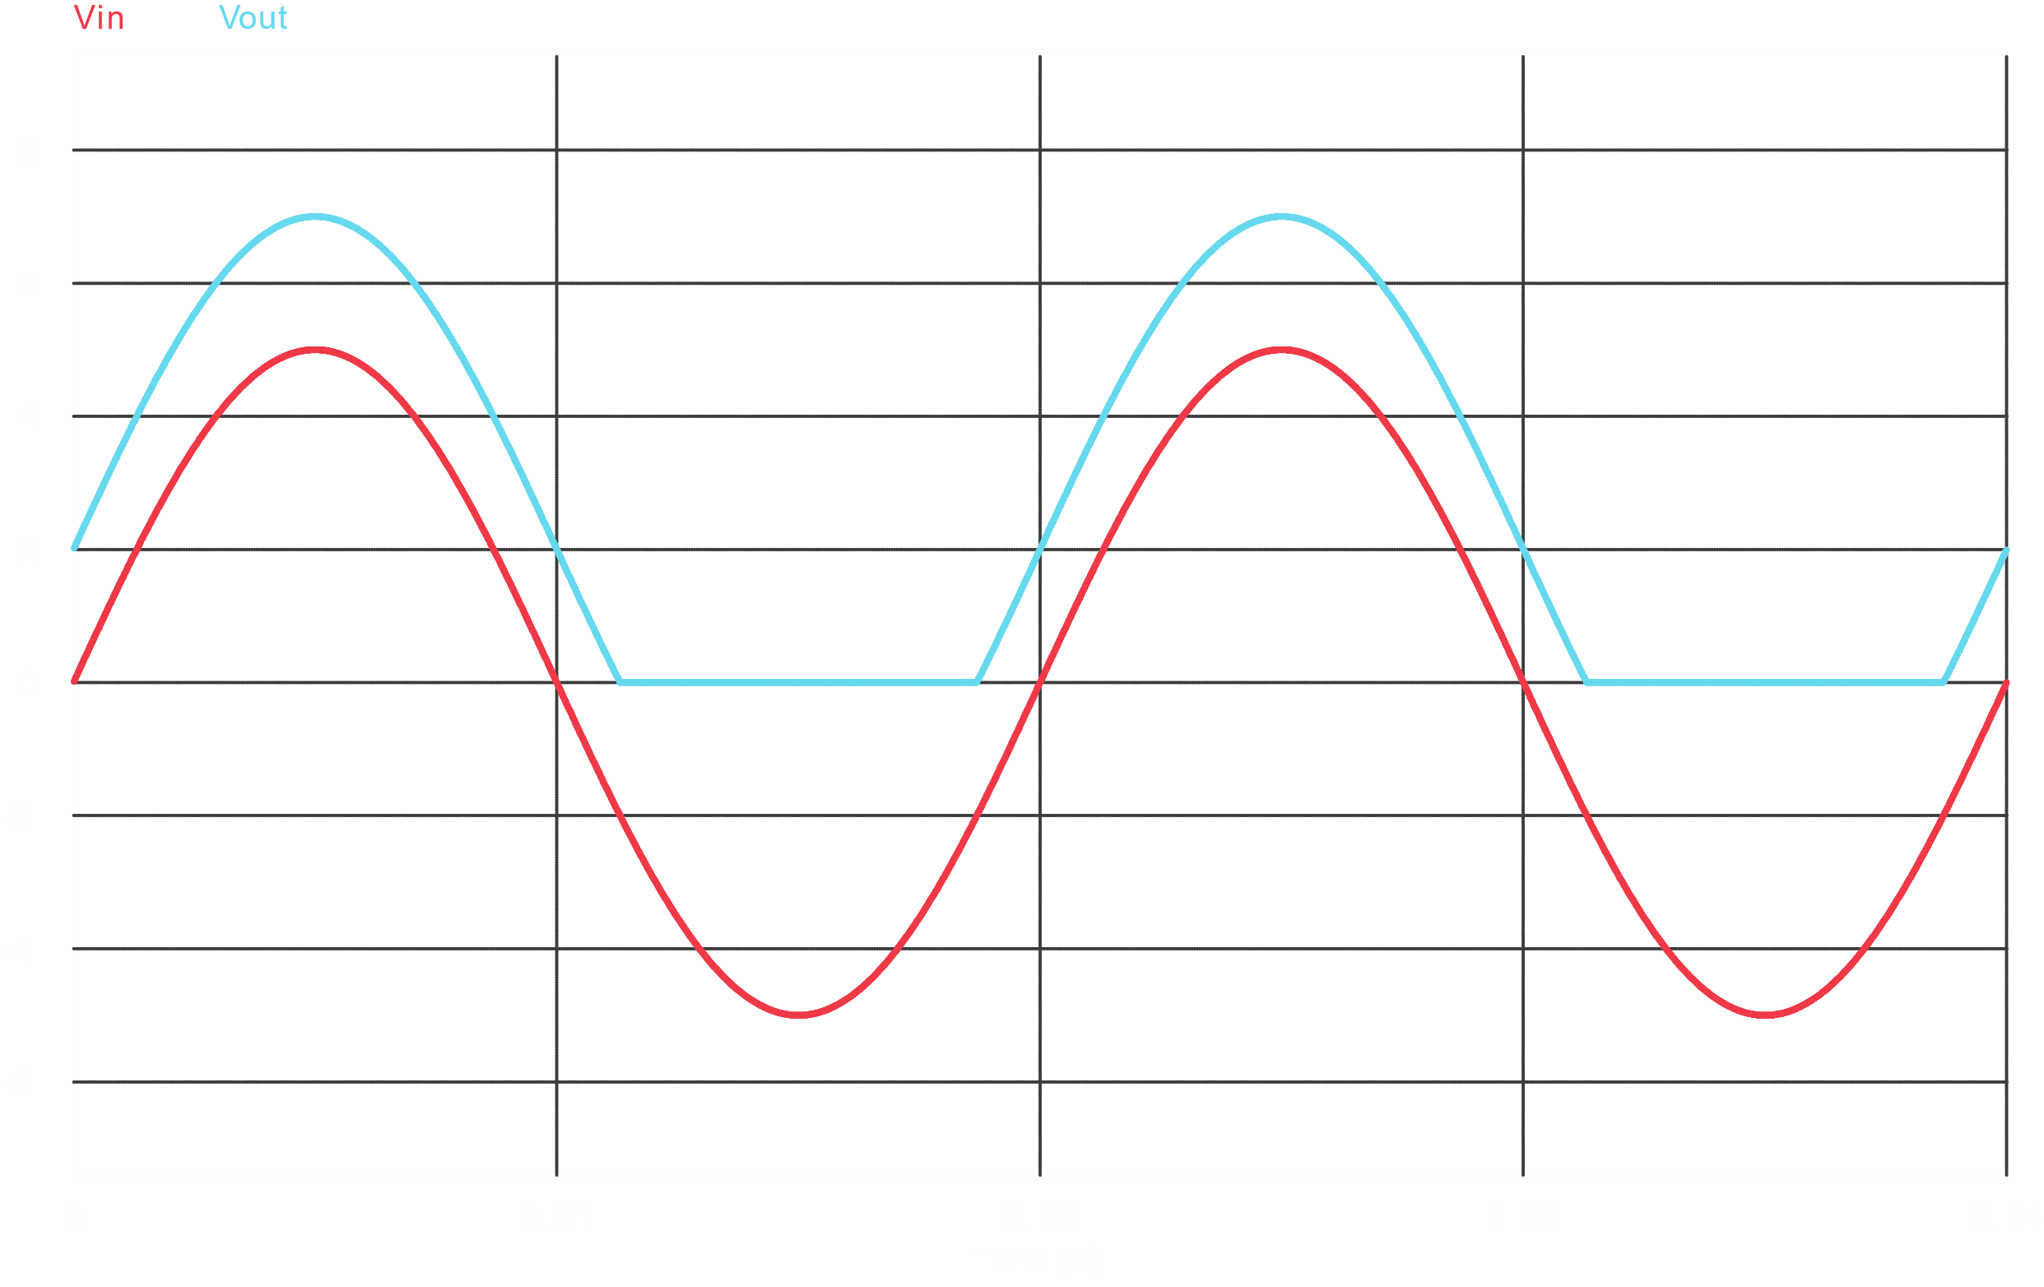

**Problem 4**

Circuit Diagram



Wave Shapes



**Problem 5**

Circuit Diagram



Wave Shapes

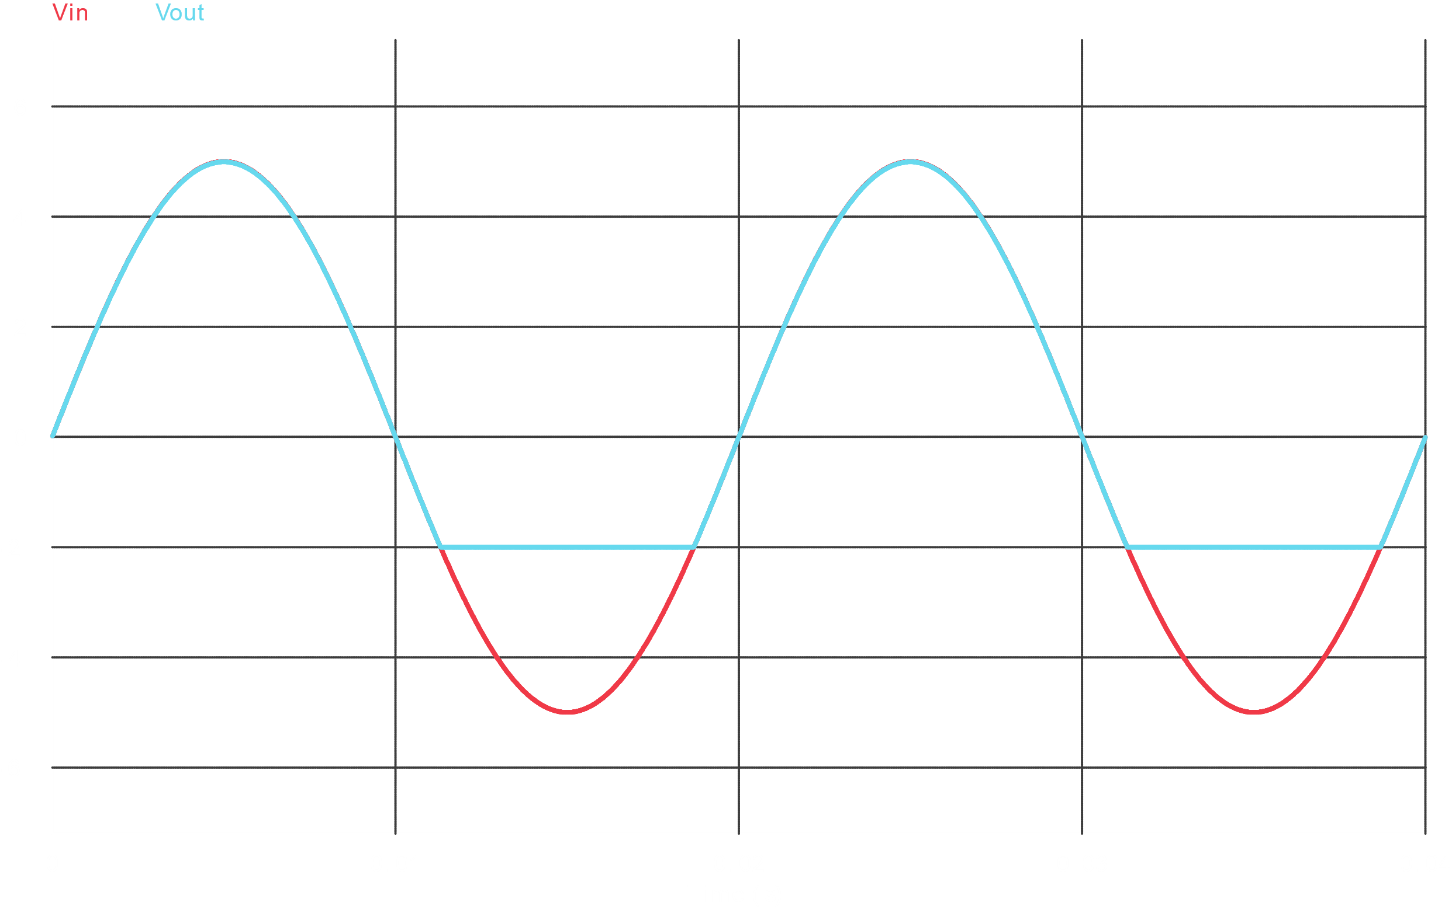

**Problem 6**

Circuit Diagram



Wave Shapes

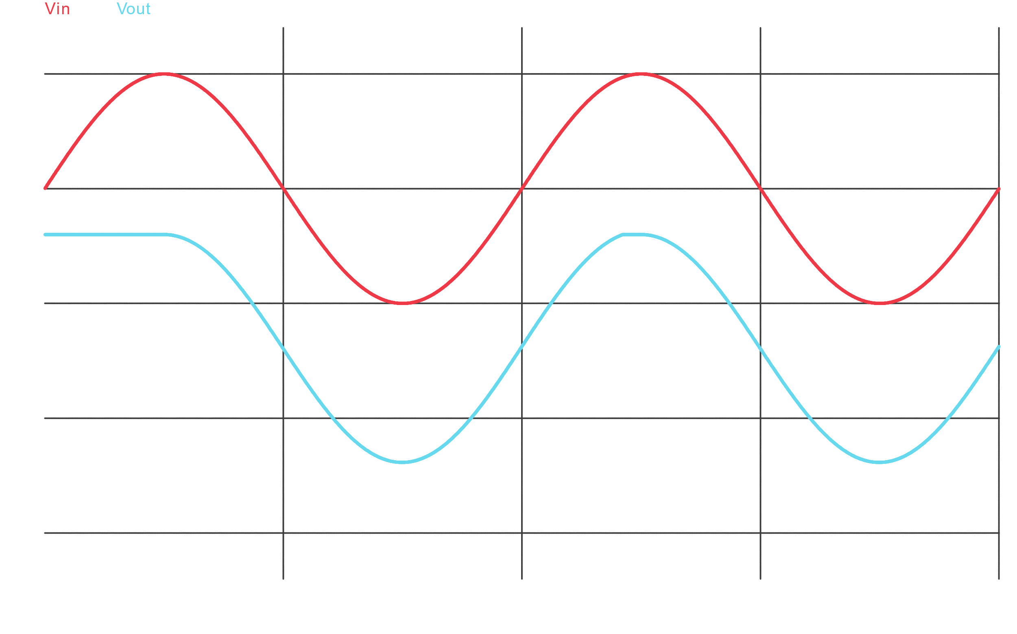

**Problem 7**

Circuit Diagram



Wave Shapes

